SCREENSHOT

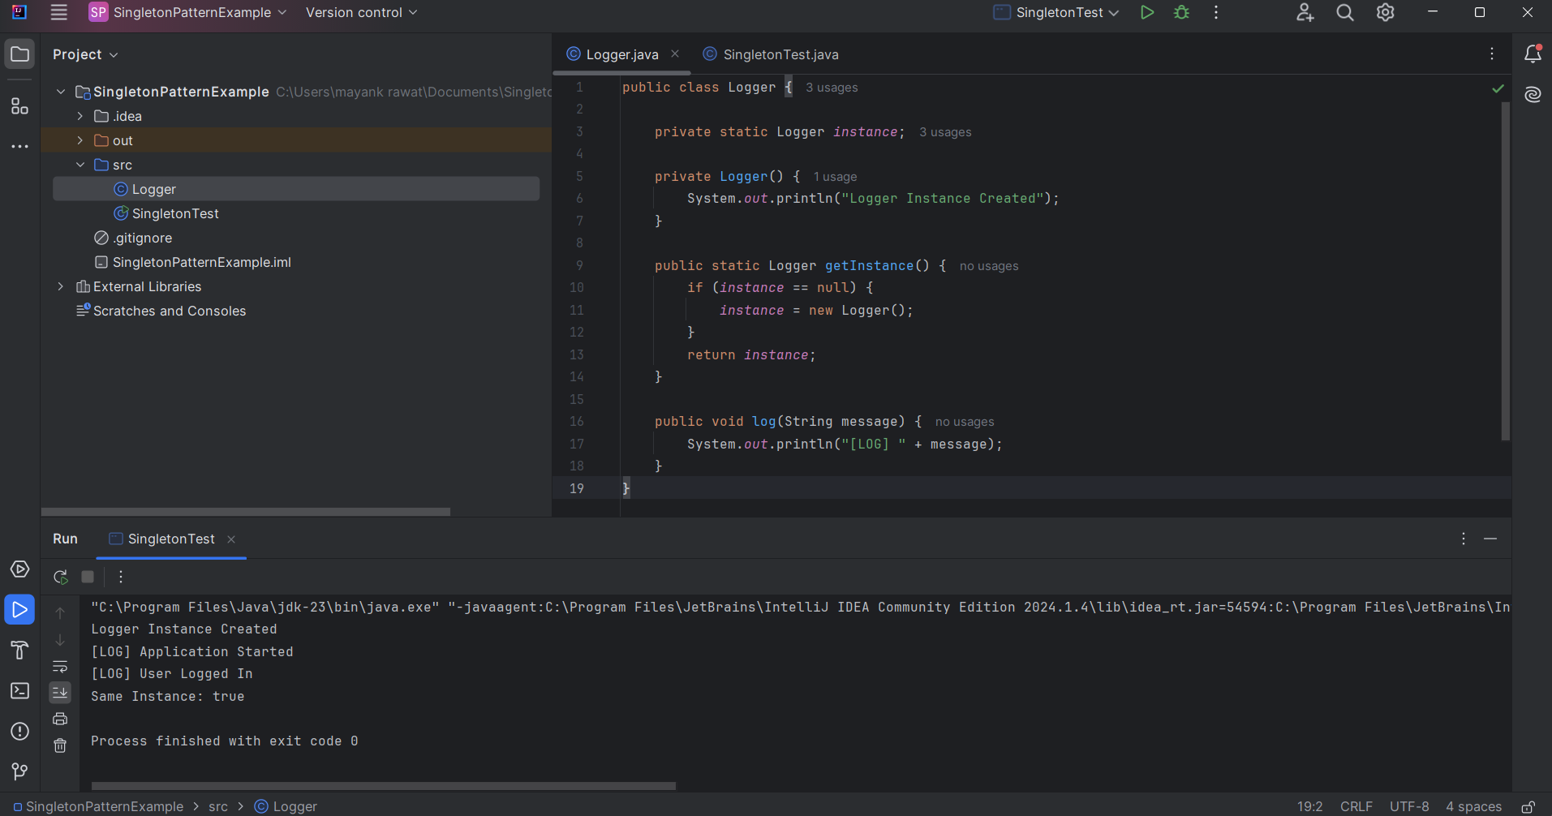

CODE
Logger.java
public class Logger {

private static Logger instance;

private Logger() {
System.out.println("Logger Instance Created");
}

public static Logger getInstance() {
if (instance == null) {
instance = new Logger();
}
return instance;
}

public void log(String message) {
System.out.println("[LOG] " + message);
}
}

SingletonTest.java

public class SingletonTest {

public static void main(String[] args) {

Logger logger1 = Logger.getInstance();
Logger logger2 = Logger.getInstance();

logger1.log("Application Started");
logger2.log("User Logged In");

System.out.println("Same Instance: " + (logger1 == logger2));
}
}

